PARTICIPANT DETAILS:

Name

NDIS Number
Address

Phone

Email

Plan Manager

Diagnosis

Alerts

GUARDIAN DETAILS (IF APPLICABLE):

Full Name:

Postal Address:

Phone:

Email:

REFERRAL DETAILS:

Full Name:

Position:

Organisation

Postal Address:

Phone:

Email:

Referral Reason

PARTICIPANT / GUARDIAN DECLARATION:
I consent to my information being provided to Collective Pathways for the purposes of referral, service delivery and inclusion in de-identified data reporting.

Full Name: __________________________
Date: _________________________
Signature of Participant / Guardian: __________________________________

Risk Assessment
When completing the Risk Assessment, refer to the below “Risk Assessment Matrix”. The Matrix asks you to consider the likelihood of something happening, and the severity if it were to occur. This then results in an overall risk rating.
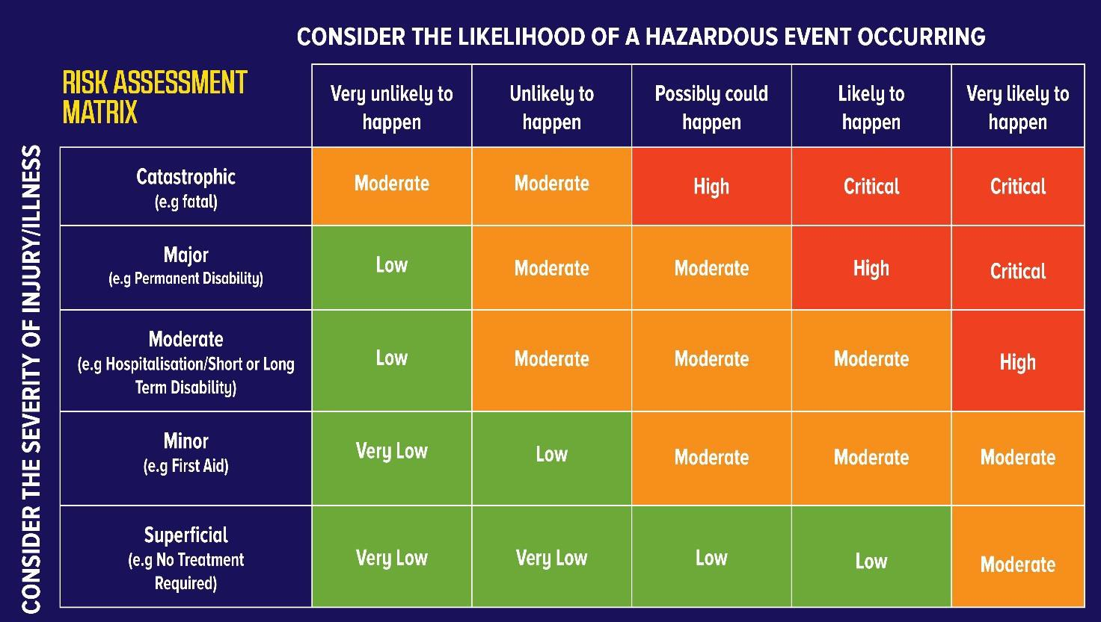
Current level of Risk | N/A | Low | Med | High
Falls | ☐ | ☐ | ☐ | ☐
Medication compliance | ☐ | ☐ | ☐ | ☐
Swallowing Concerns | ☐ | ☐ | ☐ | ☐
Absconding | ☐ | ☐ | ☐ | ☐
Self-harm | ☐ | ☐ | ☐ | ☐
Harm to others - verbal and physical aggression | ☐ | ☐ | ☐ | ☐
Drugs and alcohol | ☐ | ☐ | ☐ | ☐
Vulnerability – financial, sexual etc. | ☐ | ☐ | ☐ | ☐
Medical/health condition | ☐ | ☐ | ☐ | ☐
Housing | ☐ | ☐ | ☐ | ☐
Forensic history | ☐ | ☐ | ☐ | ☐
Other | ☐ | ☐ | ☐ | ☐

Please discuss any concerns with Risks with your Line Manager and complete the action plan below.

Risk | Action Taken to Eliminate or Control Risk | Risk Eliminated  ☐ | Risk Controlled  ☒

Date completion: | Person undertaking: | Reason: Initial risk assessment
Date edited: | Person making changes: | Reason:
Date edited: | Person making changes: | Reason:
Date edited: | Person making changes: | Reason:
Date edited: | Person making changes: | Reason:

Participant Referral
And
Risk Assessment

